## horizontal line

Early Stopping , Scaling

22.01.2025

[Early Stopping](https://colab.research.google.com/drive/1MEJk-FU8IVcGD2zYImiX-nyvOpfUgu0D)

[Feature Scaling](https://colab.research.google.com/drive/1z5OzrFe8KgJTw92r5KPuemqiYpOGOwVR)

# Early Stopping

Early stopping is a technique used while training neural networks to prevent the model from overfitting.

Overfitting is a condition when a model learns the minute patterns of the training data , not the concept . In that case it performs well on training data but poorly on test data.

It can be seen by the gap bw loss and val_loss in training a model.

Early stopping can be implemented using

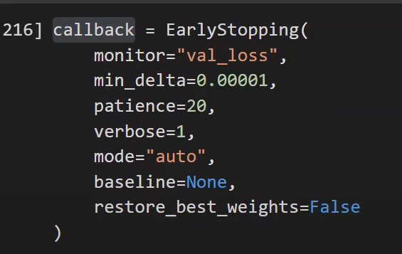

1. Monitor - which quantity to monitor.
2. Min-delta - minimum change in the quantity to quantify it as an improvement.
3. Patience - wait for how many epochs with no improvement .
4. Verbose - mode 0 or 1 , 1 displays a message when the epoch is completed .
5. Mode - (auto/min/max) training will stop if monitored quantity stops decreasing (min) , or increasing (max) , or auto model is self intelligent to see .
6. Baseline - baseline value , model stops training if model doesn’t show improvement over baseline.
7. Restore-best-weights - restore weight values during epoch for best value of monitored quantity.

# Feature Scaling

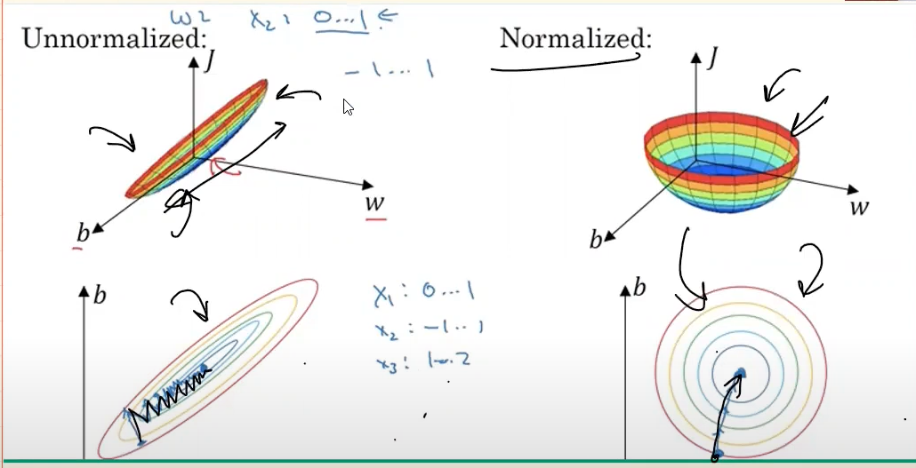

All values scaled in one range generally -1 to 1 . This embarks accuracy and model converge fastly . Training time will be less .

Two types of scaling 

Standard :

(Xi - mean)/deviation

Normalised :

(Xi - Xmin) / (Xmax - Xmin)